* **[How to edit the name of a List or Library](http://www.youtube.com/watch?v=MDghoNfbG-k)**

1. **Open Name of List/Library**

**Eg**. Library->library setting

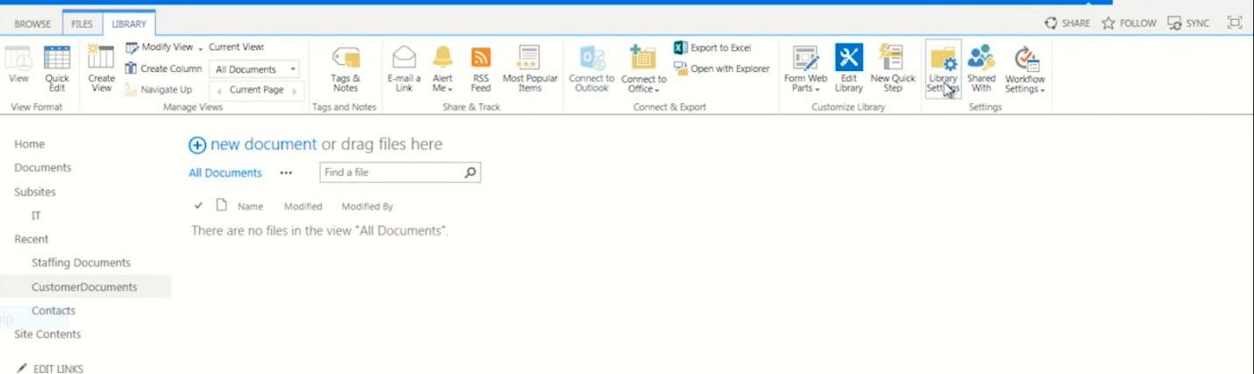

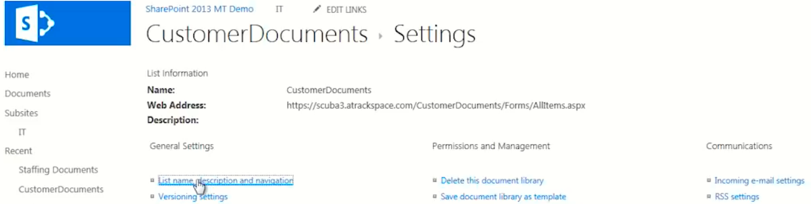

2.**Make your change**

